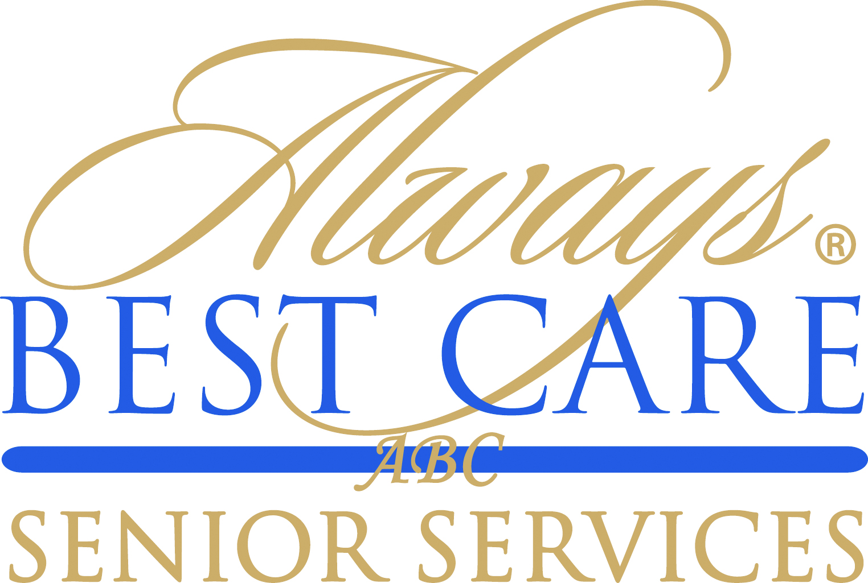

FOR IMMEDIATE RELEASE CONTACT:
August 18, 2015 Larry Miramontes
lmiramontes@abc-seniors.com
916-596-1825

Social Media Expert Matt Rubin Presents at Always Best Care international conference

Roseville, CA (August 18, 2015) – Matt Rubin, social media expert and President of Charleston-based MR. Marketing, presented “Social Media and Strategic Online Brand Development” at Always Best Care Senior Service’s 4th International Conference in San Antonio, Texas. Mr. Rubin’s presentation covered a wide range of social media topics: social posting and bookmarking, groups and content sharing, local SEO, blogging, forums and every major social media and search channel being used today: Facebook, Google, Twitter, Instagram, YouTube, Pinterest and Linkedin.
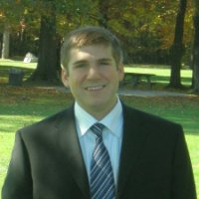

Matthew Rubin is an experienced and passionate web developer, proficient in both HTML and PHP. After working for a major agency since 2009 as an SEO Consultant, he founded MR. Marketing in 2012, an Internet marketing agency specializing in both search engine optimization and social media for franchisees and real estate agents.

Mr. Rubin is an expert on Google+ and its integration with Google Maps. He has hundreds of hours of experience optimizing Google+ and Facebook business pages for local SEO. Additionally, he is experienced in optimizing videos for local SEO on YouTube and connecting YouTube channels to Google+ business pages.

Always Best Care is one of the nation’s leading providers of non-medical in-home care, assisted living placement services and skilled home health care. The company delivers its services through an international network of more than 200 independently owned and operated franchise territories throughout the United States and Canada.
For information on Always Best Care franchise opportunities, call toll-free 1-855-430-CARE (2273), send an email to franchisesales@abc-seniors.com, or visit www.franchisewithalwaysbestcare.com.
# # #

About Always Best Care
Founded in 1996, Always Best Care Senior Services is based on the belief that having the right people for the right level of care means peace of mind for the client and family. Always Best Care assists seniors with a wide range of illnesses and personal needs, and currently provides more than 4 million hours of care every year. Franchise opportunities are available to individuals interested in leveraging the company’s clear strategy and proven track record for delivering affordable, dependable service to seniors in their local areas.

By working with case managers, social workers, discharge planners, doctors, and families, Always Best Care franchise owners provide affordable, comprehensive solutions that can be specifically matched to meet a client’s particular physical or social needs. The hallmark services of the Always Best Care business portfolio include non-medical in-home care and assisted living finder and referral services, with skilled home health care now being phased in throughout the country. For more information, visit www.AlwaysBestCare.com. For franchise opportunities, visit www.FranchiseWithAlwaysBestCare.com.

Always Best Care also offers Free ABC Rx cards, which provide discounts of up to 65 percent off the cost of prescription drugs at more than 59,000 pharmacies across the USA, and have saved consumers more than $500,000 since its inception. This service is offered at no cost to the users, there are no deductibles, no waiting periods, no pre-existing exclusions, and no eligibility requirements -- everyone can use the card (even family members and pets!). The Free ABC Rx card covers many medications that Medicare Part D and regular insurance often do not. To download a free card, visit www.FreeABCRx.com.

Another exclusive program offered by Always Best Care is Always in Touch, a telephone reassurance program that provides a daily phone call to seniors and disabled adults who are living alone and have limited contact with the outside world. Always in Touch is the only absolutely free national telephone reassurance program of its kind anywhere in the USA and Canada. For more information on Always in Touch, or to request an application, visit www.Always-in-Touch.com.

