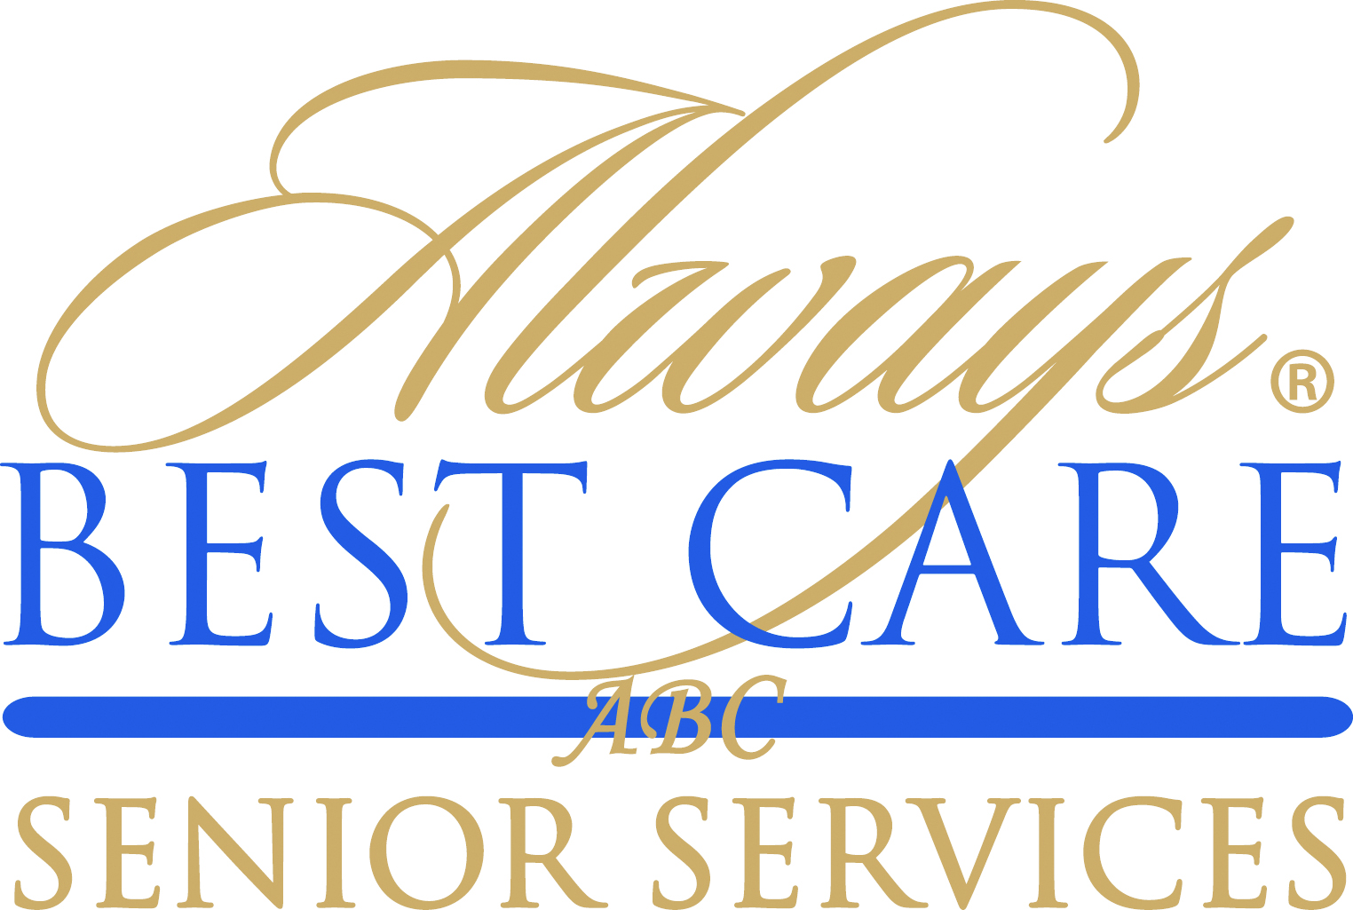

FOR IMMEDIATE RELEASE CONTACT:
Marc XX, 2016 Larry Miramontes
lmiramontes@abc-seniors.com
916-596-1825

Always Best Care Senior Services Named Top 10 Most Popular Franchising Blog

Roseville, CA (March XX, 2016) – Always Best Care Senior Services has been named one of the “Top 10 Franchising Blogs to Follow” by The Blog Herald. The senior care company was cited as a top 10 most popular franchising blog on the web, helping those looking to buy a franchise increase their knowledge and evaluate the best opportunities to start a new business.
Always Best Care is one of the nation’s leading providers of non-medical in-home care, assisted living placement services and skilled home health care. The company delivers its services through an international network of more than 200 independently owned and operated franchise territories throughout the United States and Canada.
The Blog Herald recognized Always Best Care Senior Services blog as “a blog devoted to improving operations as a franchisee in the senior care industry. It hosts current, quality conversations about how to start a franchise, find clients, avoid common mistakes, recruit and train senior caregivers, and more.”

“We are very pleased to be named a top 10 most popular blog on the web,” said Michael Newman, founder and CEO of Always Best Care Senior Services. “I am proud of this distinction as our company is one dedicated to serving as a leading resource for improved quality care for seniors and their families. Our blog helps prospective and current business owners improve their businesses which then allows us to provide the best care possible.”

Other Top 10 Franchising Blogs to Follow noted by The Bog Herald included: Hotel Law Blog, Franchise Direct, The Franchise King, Franchising.com, Entrepreneur Franchise Blog, Inc. Franchise Blog, Franchising USA Magazine, Expansion Experts and Allbusiness Franchise Blog.

The Blog Herald is a premier source of news, information, tips, and commentary on blogs, the blogging industry and bloggers worldwide. It has often been cited by both the mainstream media and bloggers as a reliable source of facts, figures, opinion and trends about blogging. Founded by Duncan Riley in March 2003 as a premium source of blog and blogging related news for bloggers, the Blog Herald was the first blog dedicated exclusively to the news of the blogosphere and remains the longest (and largest) standing resource of its kind.

For information on Always Best Care franchise opportunities, call toll-free 1-855-430-CARE (2273), write to us at franchisesales@abc-seniors.com, or visit www.franchisewithalwaysbestcare.com.

# # #

About Always Best Care
Founded in 1996, Always Best Care Senior Services is based on the belief that having the right people for the right level of care means peace of mind for the client and family. Always Best Care assists seniors with a wide range of illnesses and personal needs, and currently provides more than 4 million hours of care every year. Franchise opportunities are available to individuals interested in leveraging the company’s clear strategy and proven track record for delivering affordable, dependable service to seniors in their local areas.
By working with case managers, social workers, discharge planners, doctors, and families, Always Best Care franchise owners provide affordable, comprehensive solutions that can be specifically matched to meet a client’s particular physical or social needs. The hallmark services of the Always Best Care business portfolio include non-medical in-home care and assisted living finder and referral services, with skilled home health care now being phased in throughout the country. For more information, visit www.AlwaysBestCare.com. For franchise opportunities, visit www.FranchiseWithAlwaysBestCare.com.
Always Best Care also offers Free ABC Rx cards, which provide discounts of up to 65 percent off the cost of prescription drugs at more than 59,000 pharmacies across the USA, and have saved consumers more than $500,000 since its inception. This service is offered at no cost to the users, there are no deductibles, no waiting periods, no pre-existing exclusions, and no eligibility requirements -- everyone can use the card (even family members and pets!). The Free ABC Rx card covers many medications that Medicare Part D and regular insurance often do not. To download a free card, visit www.FreeABCRx.com.
Another exclusive program offered by Always Best Care is Always in Touch, a telephone reassurance program that provides a daily phone call to seniors and disabled adults who are living alone and have limited contact with the outside world. Always in Touch is the only absolutely free national telephone reassurance program of its kind anywhere in the USA and Canada. For more information on Always in Touch, or to request an application, visit www.Always-in-Touch.com.

